**Champions League**

The dataset used for this project is of champions league and this data set conations total 62 columns and total 747 rows. The column names are **player_name, club, position, minutes_played_x, match_played_x, goals_x, assists_x, distance_covered, serial_x, assists_ycorner_taken, offsides, dribbles, match_played_y, serial_y, total_attempts, on_target, off_target, blocked, match_played_x.1, serial_x.1, balls_recoverd_x, tackles_x, t_won_x, t_lost_x, clearance_attempted_x, match_played_y.1, serial_y.1, Unnamed: 4, balls_recoverd_y, tackles_y, t_won_y, t_lost_y, clearance_attempted_y, minutes_played_y, match_played_x.2, serial_x.2, saved, conceded, saved_penalties, cleansheets, punches_made, match_played_y.2, serial_y.2, goals_y, right_foot, left_foot, headers, others, inside_area, outside_areas, penalties, match_played_x.3, serial, pass_accuracy, pass_attempted, pass_completed, cross_accuracy, cross_attempted, cross_complted, freekicks_taken and match_played_y.3.** There are 4 columns of type object, 4 columns of type integer and 46 columns are of type float.

**Analysis**

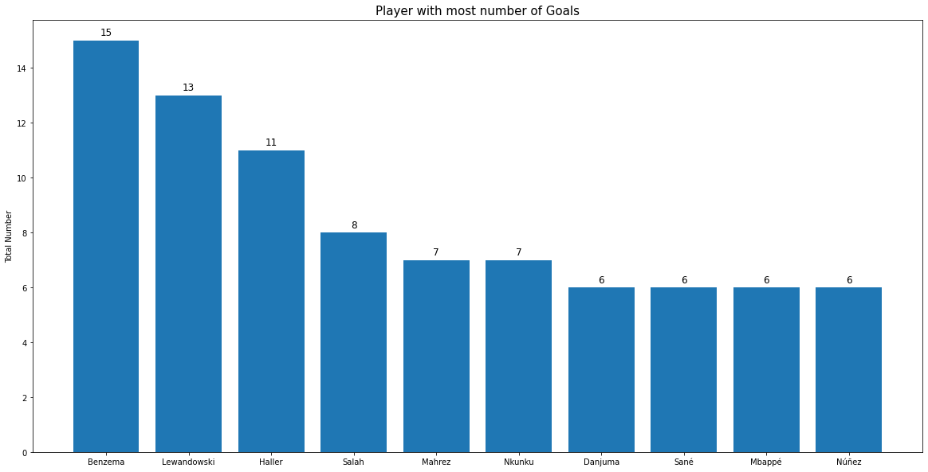**Top 10 players with most number of goals**

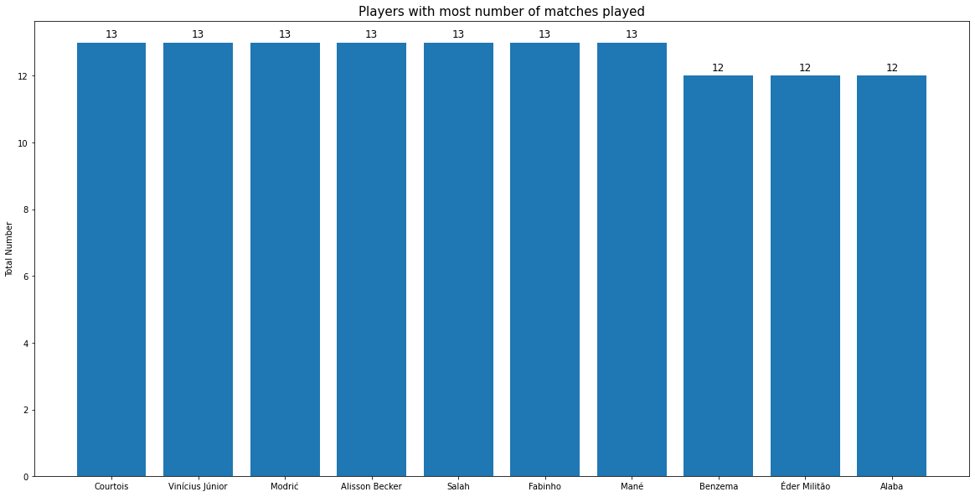**Top 10 players with most number of matches Played**

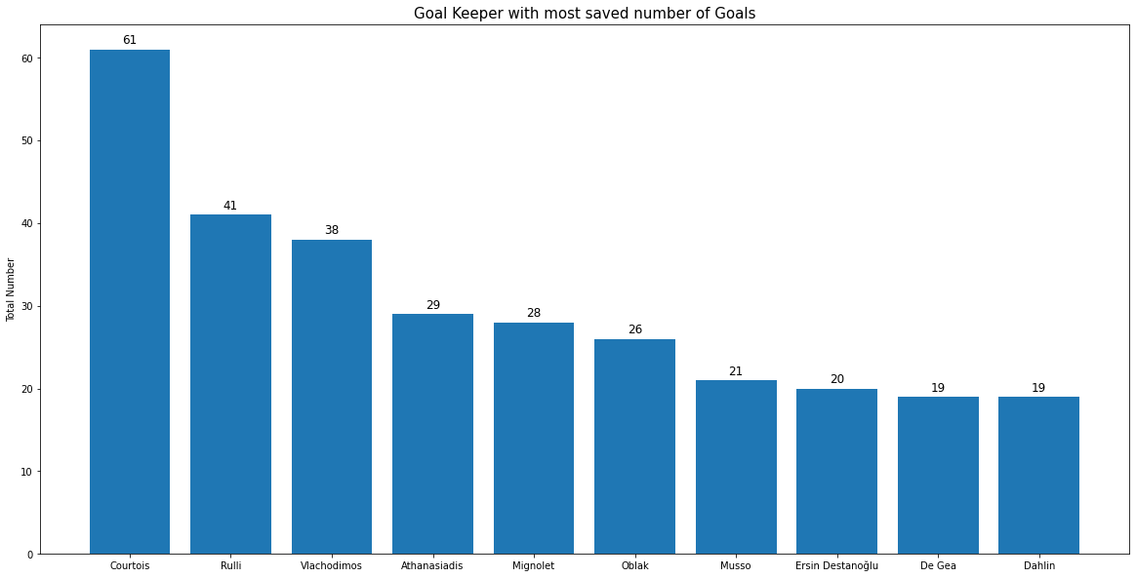**Top 10 Goal Keepers with most number of saved Goals**

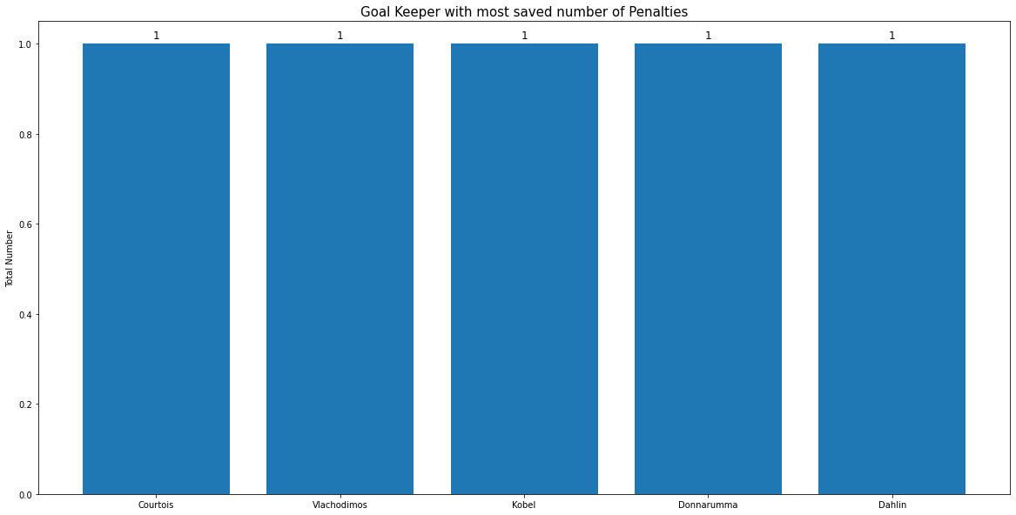**Goal Keepers with most number of saved Penalties**

**Top 10 players with most number of defends**

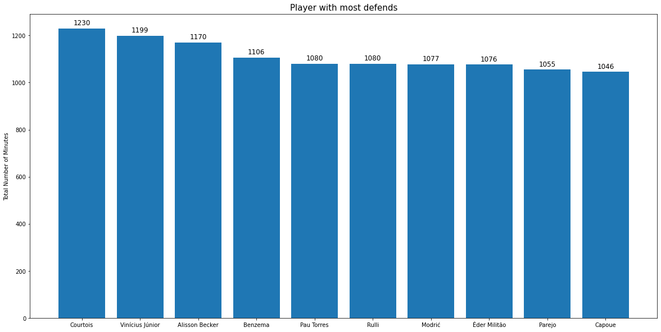**Top 10 players with most number of minutes played**

**Top 10 Mid-Fielder players with most number of balls recovered**

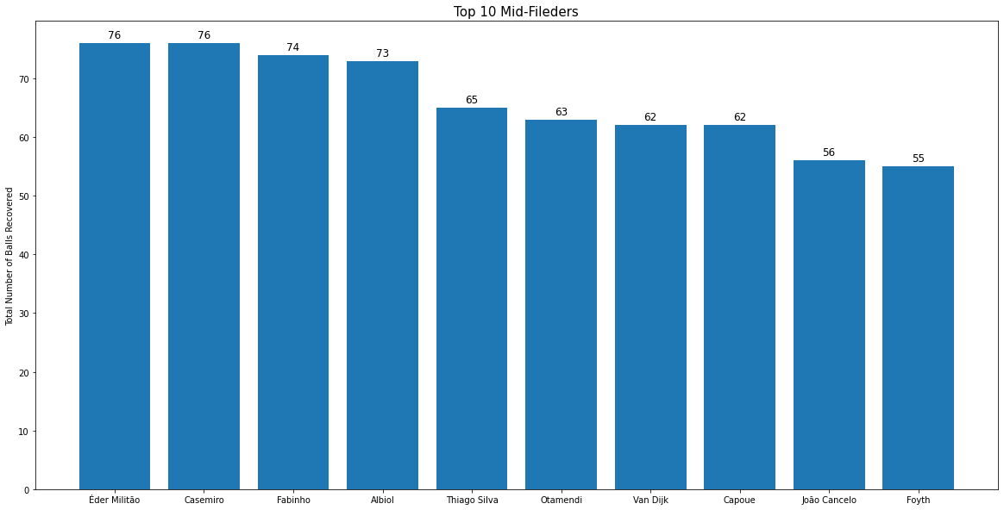

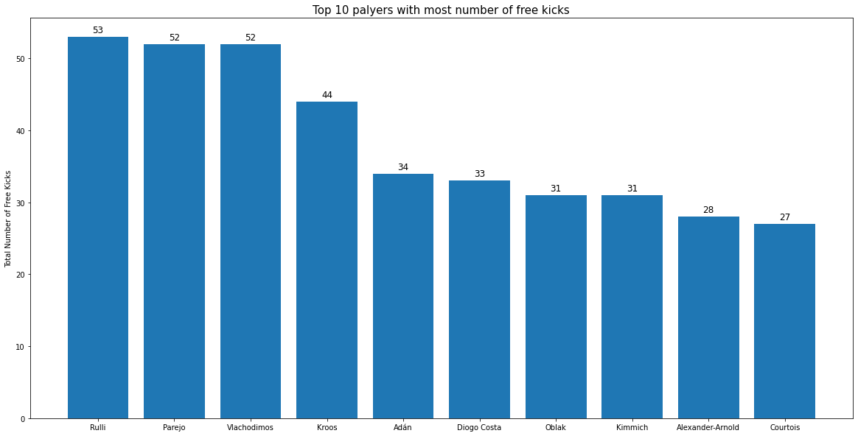**Top 10 players with most number of free kicks**

**Top 10 Goal Keepers with most number of Goal Conceded**

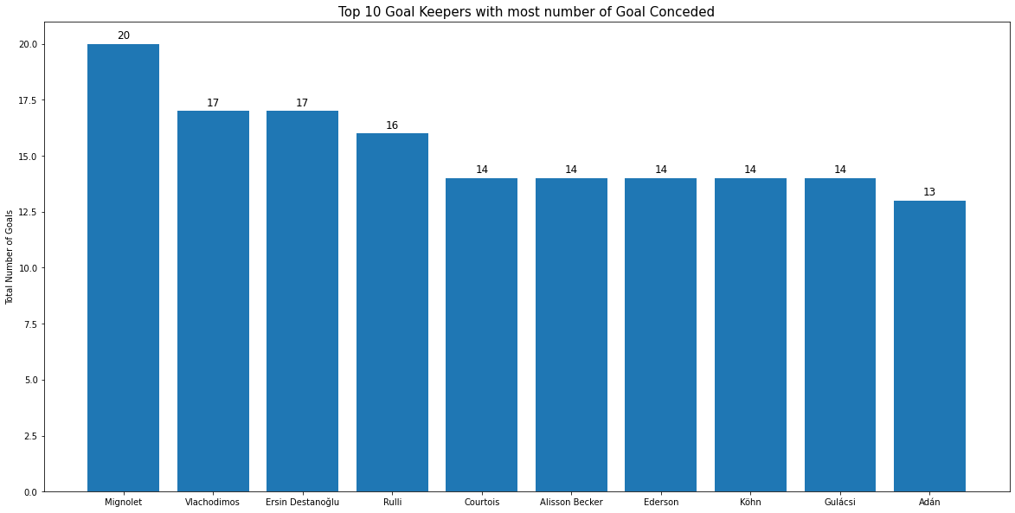

**Principal Component Analysis (PCA)**

In order to find best attributes for each position, the data is filtered according to the position. There is total 4 playing positions which are **'Goalkeeper', 'Forward', 'Midfielder' and ‘Defender'.**

**Goalkeeper**

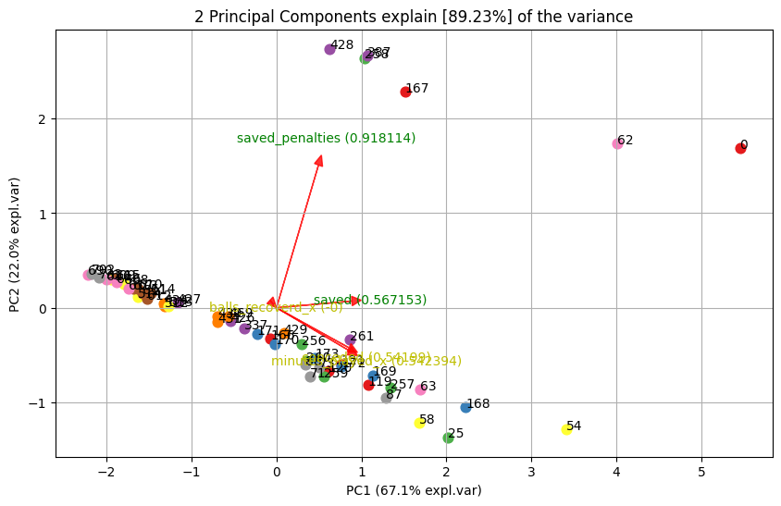For Goalkeeper position the selected feature columns are **'saved_penalties', 'saved','conceded', 'balls_recoverd_x' and 'minutes_played_x'.** After applying PCA the results obtained are shown below.

From image and table results the two best attributes for Goalkeeper position are how much goals and penalties are saved by the goalkeeper.

**Forward**

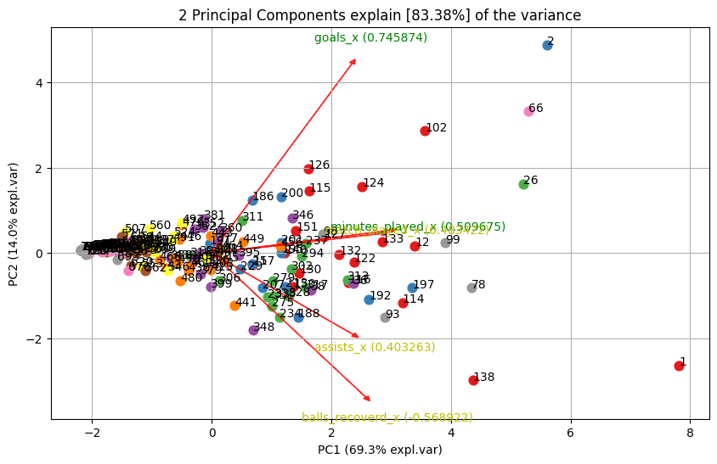For Forward position the selected feature columns are **'goals_x', 'assists_x','balls_recoverd_x', 'minutes_played_x' and 'match_played_x'.** After applying PCA the results obtained are shown below.

From image and table results the two best attributes for Forward position are how many minutes is played by the player and how much goals are scored by the player.

**Midfielder**

For Midfielderposition the selected feature columns are **'goals_x', 'assists_x', ‘balls_recoverd_x', 'minutes_played_x', 'blocked' and 'match_played_x'.** After applying PCA the results obtained are shown below.

From image and table results the two best attributes for Midfielder position are how many minutes is played by the player and how many times he has recovered the ball.

**Defender**

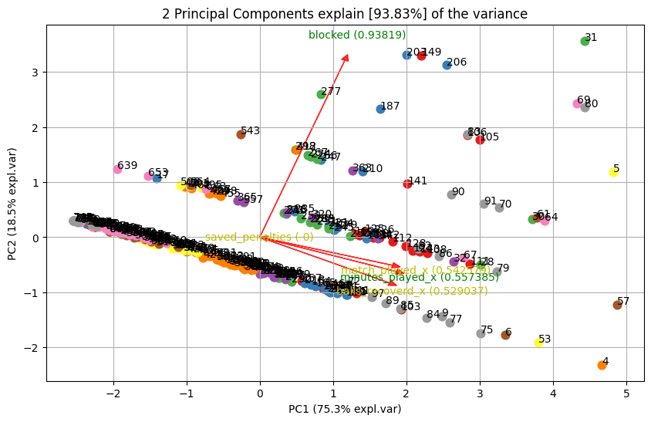For Defenderposition the selected feature columns are **'balls_recoverd_x', ‘minutes_played_x', 'blocked', 'saved_penalties' and 'match_played_x'.** After applying PCA the results obtained are shown below.

From image and table results the two best attributes for Defender position are how many minutes is played by the player and how many times he has blocked the ball.